Guess Paper – 2013
Class – IX
Subject – Science

Total marks : 90 | Total time: 3:00 Hrs
Test instructions: General Instructions:
i) The question paper comprises of two sections, A (Question No. 1 to 24)and B (Question No. 25 to 42), you are to attempt both the sections.
ii) All questions are compulsory.
iii) There is no overall choice. However, internal choice has been provided in all the five questions of five marks category. Only one option in such questions is to be attempted.
iv) All questions of section A and all questions of section B are to be attempted separately.
v) Question numbers1 to 3 in section A are one mark question. These are to be answered in one word or one sentence.
vi) Questions numbers 4 to 7 are two marks questions, to be answered in about 30 words.
vii) Question numbers 8 to 19 are three marks questions, to be answered in about 50 words.
viii) Question numbers 20 to 24 are five marks questions, to be answered in about 70 marks.
ix) Question numbers 25 to 42 in section B are multiple choice questions are based on practical skills. Each question is a one mark question. You are to choose one most appropriate response out of the four provided to you.

Questions:

1] | When do we say that work is done?
2] | What is an atom?
3] | Name two processes that play an important role in oxygen cycle.
4] | Distinguish between loudness and intensity of sound.
5] | (a) How many cotyledons are present in the seeds of monocots and dicots?  (b)Why do bryophytes called as amphibians of the plant kingdom?
6] | (a) Name the carbon compound responsible for depletion of ozone.  (b) What are the different states in which water is found during the water cycle?
7] | List one similarity and one difference between fungi and plant.
8] | Draw a neat diagram of human ear and label external ear, middle ear and inner ear.
9] | A man whose mass is 50 kg climbs up 30 steps of the stairs in 30 seconds. If each step is 20 cm high, calculate the power used in climbing the stairs.
10] | (a) Two children are at opposite ends of an aluminium rod. One strikes the end of the rod with a stone. Find the ratio of times taken by the sound wave in air and in aluminium to reach the second child.  (b) What is the consequence of two sound waves which arrive at the ear in a time interval shorter than 0.1 s?
11] | Calculate the force exerted by the brakes when a motor car weighing 2000kg travelling at 20 ms⁻¹ stops at a distance of 50m retarding uniformly. Also calculate the work done by the brakes.
12] | Distinguish between transverse waves and longitudinal waves.
13] | What is the mass of?  (i) 0.2 mole of oxygen atoms?  (ii) 0.5 mole of water molecules?
14] | (a) What is the significance of symbols?  (b) Define the atomic mass unit.  (c) Why is it not possible to see an atom with naked eyes?
15] | (a) Draw a sketch of Bohr's model of an atom with three shells.  (b) If K and L shell of an atom are full, then what would be the total number of electrons in the atom?  (c) What is the charge on protons?
16] | What precautions can you take in your school to reduce the incidence of infectious diseases? Mention any three points.
17] | (a) Who discovered vaccine for the first time?  (b) What is an antibiotic? Give two examples.
18] | (a) Give one word for:  (i) Diseases which can spread from one person to another.  (ii) Diseases which are present since birth.  (iii) Diseases which last for short duration.  (iv) Diseases which last for longer duration.  (b) What is vaccination?
19] | (a) Define  (i) Vector  (ii) Carrier  (b) What are the modes of transmission of AIDS?
20] | (a) What is transformation of energy? Explain with any two suitable examples.  (b) What must be the velocity of a moving body of mass 2 kg so that its K.E. is 25 J?  (c) Represent graphically constant force acting on a body producing a displacement along the direction of motion on a force-displacement graph. What is the significance of force-displacement graph?  Or  (a) Define potential energy. Give two examples.  (b) Two bodies of different masses m₁ and m₂ (m₁ > m₂) have same kinetic energy. They are stopped by applying same retarding force. Which body will stop first?
21] | State and prove Archimedes' principle.  Or  What are multiple echoes? Discuss their important practical applications.
22] | 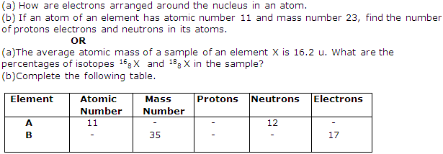
23] | 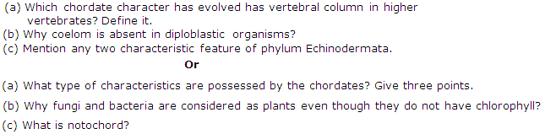
24] | (a) What would be the impact of increase in the concentration of carbon dioxide in the atmosphere?  (b) (i) What do you mean by biogeochemical cycles? Name any two of the Biogeochemical cycles.  (ii) Nitrogen cycle is called a perfect cycle in nature. Explain.  Or  (a) (i) Name two agents of soil erosion  (ii) Write any two steps used to control soil erosion.  (b) A forest area has cleaned by cutting trees for industrialisation purpose. List any two changes that will be brought in the water cycle of that area.
25] | If we want to determine the volume of a solid by immersing it in water, the solid should be
A. | Any solid
B. | Heavier than water
C. | Insoluble in water
D. | Heavier than water and insoluble in it

26] | S.I. unit of weight is
A. | 1 kg
B. | 1 g
C. | 1 g wt
D. | 1 N

27] | A spring balance
A. | Can measure weight only.
B. | Is used to determine density.
C. | Is used to measure mass only.
D. | May be used to determine mass as well as weight.

28] | 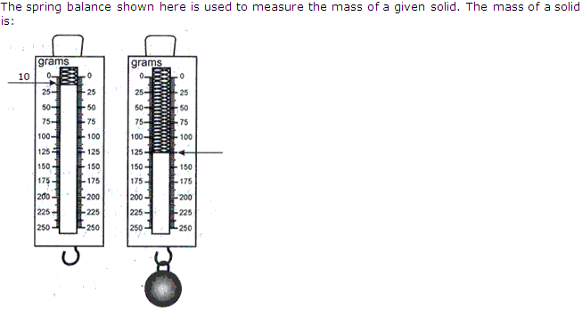
A. | 118g
B. | 120g
C. | 125g
D. | 115g

29] | Density of salty water as compared to the density of pure water
A. | is less
B. | is equal
C. | may be less or more
D. | is always more

30] | Which principle tells us about the decrease in weight of a body when immersed in a liquid?
A. | Pascal's law
B. | Avogadro's law
C. | Boyle's law
D. | Archimedes' law

31] | Sound waves in air are:
A. | Transverse waves
B. | Shock waves
C. | Radio waves
D. | Longitudinal waves

32] | The thread used to tie a solid should be
A. | As fine as possible
B. | Thick
C. | A metallic wire
D. | Fine but strong enough

33] | What is the correct statement of the 'Law of Conservation of Mass'?
A. | The elements are always present in a constant proportion in a chemical substance.
B. | If two elements form more than one compound between them, then the ratios of the masses of the second element which combine with a fixed mass of the first element will be ratios of small whole numbers.
C. | The rate of reaciton is directly proportional to the active mass of the reactants.
D. | That mass can neither be created nor be destroyed.

34] | According to Law of conservation of mass of reactants wil be equal to the mass of
A. | Catalysts
B. | Heat released
C. | Heat absorbed
D. | Products

35] | 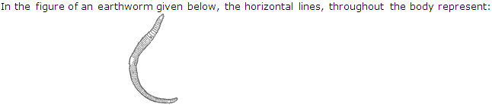
A. | Cells of the body.
B. | Cell walls separating the cells of the body.
C. | Vertically arranged muscles of the body.
D. | Septa separating segments of the body.

36] | Thallophyta is a group of plants which:
A. | Bear flowers.
B. | Have well developed roots, stem and leaves.
C. | Have naked seeds.
D. | Do not have well differentiated body.

37] | The exoskeleton of cockroach is made up of:
A. | Cartilage
B. | Calcium and phosphorous
C. | Cellulose
D. | Chitin

38] | Bala observed the position of mouth in a bony fish as:
A. | Dorsally placed
B. | Ventrally placed
C. | Anteriorly placed
D. | Terminal placed

39] | 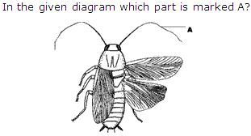
A. | Jointed legs
B. | Mouth part
C. | Spiracle
D. | Antenna

40]
A. | Gills
B. | Pilius
C. | Annulus
D. | Stipe

41] | The sub division of Spirogyra is:
A. | Fungi
B. | Bryophyta
C. | Pteridophyta
D. | Algae

42] | 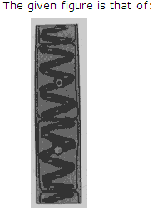
A. | Ulothrix
B. | Chlamydomonas
C. | Cladophora
D. | Spirogyra

APEX INSTITUTE FOR IIT-JEE /AIEEE / DCE, 0120-4901457, +919990495952, +919910817866 www.apexiit.co.in/

